**RUNNING XDAY ON JOB COMPOSER**

Submitting a Job

1. Log onto Great Lakes
2. Under +New Jobs, Choose Specified Path option
3. All files required to run xday should be in:
   1. /nfs/turbo/umms crburge/Code/AF/newPipeline/pipe.cb/greatlakes/xday
4. Fill out all information in required and optional, name should be xdayANIMALID (example: xdayW10)

1. A new job should have been created with status “not submitted”



The job detail should look like this:

-don’t worry about the script location, greatlakes creates a temporary (?) directory that stores the job script

-make sure the folder contains all the files needed to run including the script file (.sh)

1. Checking “Submit Script” – the contents of submit script will be displayed in a text box that can be changed in the browser editor

#!/bin/bash

#SBATCH --job-name=xDayTest

#SBATCH --mail-user=alchiu@umich.edu

#SBATCH --mail-type=BEGIN,END,FAIL

#SBATCH --cpus-per-task=36

#SBATCH --mem=18000

#SBATCH --nodes=1

#SBATCH --ntasks-per-node=1

#SBATCH --time=01-2:00:00

#SBATCH --account=alchiu

#SBATCH --partition=standard

module load matlab/R2020a

matlab -nodisplay < xdaystartup.m

Things to change for each job

* 1. Job-name =xDayANIMALID
  2. mail-user=whatever email to be notified at
  3. CPU/Memory= TBD
  4. time= dd-hr-mm-ss (always anticipate more time than you need)

notes for me:

mouse ID with the stim dir

1. Submit job and check email to confirm status

The job manager will send you an update if the job **fails** with an exitcode #

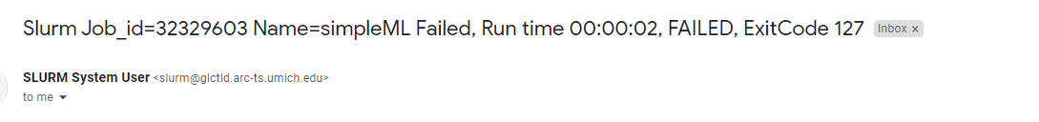

or if the job has **completed**

1. If a new job script is used you may get this error



Open terminal (will require level 1 password and duo)

Type dos2unix filename (.sh file).

